

**INDEX**

**ABSTRACT 2**

**I – INTRODUCTION 3**

1. Objective ………………………………………………………………………..4

2. Title ……………………………………………………………………………..4

**II – INITIAL PREPARATION 4**

1. Timeline ……………………………………………………………………… ..4

2. Design process …………………………………………………………………..6

3. Gantt chart ………………………………………………………………………8

4. Initial Fusion …………………………………………………………………….8

5. Materials ………………………………………………………………………..9

**III – PROTOTYPE 9**

1. Prototype 1……………………………………………………………………...9.

2. Protoype 2…………………………………………………………………… 10

3. Prototype 3……………………………………………………………………..11

4. Fee…………………………………………………………………………… ..14

**IV – PRODUCT 15**

1. Final 3D – design ……………………………………………………………...15

2. Electrical devices ( Number pad)……………………………………………….17

3. Code written……………………………………………………………………17

4. Final product…………………………………………………………………...17

5. Story of the toy…………………………………………………………………23

6. Principle………………………………………………………………………..24

7. Price……………………………………………………………………………26

**V – COLLECT DATA AND ANALYSIS 27**

1. Testing………………………………………………………………………….27

2. Validation………………………………………………………………………28

2.1. Data from disable children…………………………………………….28

2.2. Data from normal children ……………………………………………32

2.3. Analysis and Validation………………………………………………36

**VI – DISCUSSION 37**

**VII – WORKING PLANNING 38**

**VIII – REFERENCE 39**

**ABSTRACT**

**KNOWLEDGEMENT**

**I – INTRODUCTION :**

1. **Objective:**

Design and build an appropriate toy to predict the level thinking for children with disabilities.

Apply the knowledge of engineering to:

Chose the best solution.

Make nice details.

Develop the simple and amazing system.

Understand and practice to do the project step-by-step.

Improve a lot of skills: teamworks skill, presentation skill, critical thinking skill, leadership skill, handmade skill, 3D design skill, time management skill,...

Complete all of products in project before deadline.

1. **Title:**

**CONQUER THE STARS**

A person controls an UFO (unidentified flying object) which has modern technology can drop the full of energy in an aerolite to destroy not only subjects but also a planet. Lucifer system which is threatening to solar system includes ten planets like as the stars. Mission’s people are breaking all of planets in Lucifer system, then remain the peaceful planet on The Earth.

**II – INITIAL PREPARATION:**

**1. Timeline:**

|  |  |  |  |  |
| --- | --- | --- | --- | --- |
| **Order** | **Start day** | **Due day** | **Works** | **Note** |
| 1 | 15/10/2019 | 20/10/2019 | - Create the initial idea for project.  - Design 3D by Fusion.  - Think about principle of the toy.  - Design cover. | Vy  Sáng  Minh |
| 2 | 20/11/2019 | 27/11/2019 | - Buy materials: foam paper, magnet, paper-knife.  - Print the numbers to paste on the top side. | Huyền  Vy |
| 3 | 27/11/2019 | 27/11/2019 | - Making UFO  - Completing the box system  - Operating the magnet.  - Pasting the numbers on top side.  - Buying mica. | Sáng, Minh, Huyền, Vy |
| 4 | 7/12/2019 | 7/12/2019 | - Buying registers, LCD, magnet.  - Apply questions in test. And coded by arduino.  - Completing the mica box, stick LCD on the toy.  - Pasting the background. | Sáng, Minh, Huyền, Vy |
| 5 | 9/12/2019 | 9/12/2019 | - Buying I2C, jumpers,…  - Use electrical devices on number pad. | Minh |
| 6 | 10/12/2019 | 10/12/2019 | - All member prepare to operate the toy tomorrow  - Checking code.  - Decorating objects in system.  - Apply electricity on LED and number pad, checking them certainly. | Sáng, Minh, Huyền, Vy |
| 7 | 20/12/2019 | 20/12/2019 | Testing at Specialized School | Minh, Vy |
| 8 | 23/12/2019 | 23/12/2019 | Testing at Trường giáo dục chuyên biệt Khai Trí | Huyền, Minh, Vy |
| 9 | 28/12/2019 | 30/12/2019 | - Fusion  - Story  - Code improvement  - Final report | Vy  Sáng  Sáng  Huyền |
| 10 | 29/12/2019 | 31/12/2019 | - Final poster | Minh |

1. **Design process:**
2. Project begins
3. Literature study
4. Concept develop
5. Initial requirement
6. Final solution
7. Design 3D
8. Develop prototype
9. Final prototype
10. Project completed

|  |  |  |
| --- | --- | --- |
|  | Activity | Duration (week) |
| 1 – 2 | Read the literature | 2 |
| 1 – 3 | Initial idea and concept development | 3 |
| 1 – 4 | Purchase equipment | 1 |
| 2 – 5 | Analysis the best possible direction for the solution | 2 |
| 2 – 6 | Base on the literature to upgrade the draft board | 3 |
| 3 – 5 | Determine and development process | 2 |
| 4 – 7 | Build the prototype | 4 |
| 5 – 6 | Base on the final solution to development to draw the 3D design | 4 |
| 5 – 7 | Do the prototype which is suitable with the solution | 6 |
| 6 – 7 | Build the prototype base on the 3D design | 4 |
| 6 – 8 | Test the specifications of prototype | 1 |
| 7 – 8 | Test, upgrade the prototype | 2 |
| 8 – 9 | Presentation with the final prototype | 1 |

Total time to complete Introduction to BME poject: 36 week.

**Critical path method:**

**2,3,1**

**1,7,6**

**13,13,0**

2

**11,11,0**

**7,7,0**

2

**5,5,0**

**3,3,0**

**0,0,0**

1

1

4

2

4

3

1

2

3

2

2

**14,14,0**

The critical time: 14 weeks

The critical path form 1 🡪 3 🡪 5 🡪 6 🡪7 🡪8 🡪9

1. **Gantt chart:**

|  |  |  |  |  |  |  |  |  |  |  |  |  |  |  |
| --- | --- | --- | --- | --- | --- | --- | --- | --- | --- | --- | --- | --- | --- | --- |
| 0 | 1 | 2 | 3 | 4 | 5 | 6 | 7 | 8 | 9 | 10 | 11 | 12 | 13 | 14 |
| 1 – 2 |  |  |  |  |  |  |  |  |  |  |  |  |  |  |
| 1 – 3 |  |  |  |  |  |  |  |  |  |  |  |  |  |  |
| 1 – 4 |  |  |  |  |  |  |  |  |  |  |  |  |  |  |
| 2 – 5 |  |  |  |  |  |  |  |  |  |  |  |  |  |  |
| 2 – 6 |  |  |  |  |  |  |  |  |  |  |  |  |  |  |
| 3 – 5 |  |  |  |  |  |  |  |  |  |  |  |  |  |  |
| 4 – 7 |  |  |  |  |  |  |  |  |  |  |  |  |  |  |
| 5 – 6 |  |  |  |  |  |  |  |  |  |  |  |  |  |  |
| 5 – 7 |  |  |  |  |  |  |  |  |  |  |  |  |  |  |
| 6 – 7 |  |  |  |  |  |  |  |  |  |  |  |  |  |  |
| 6 – 8 |  |  |  |  |  |  |  |  |  |  |  |  |  |  |
| 7 – 8 |  |  |  |  |  |  |  |  |  |  |  |  |  |  |
| 8 – 9 |  |  |  |  |  |  |  |  |  |  |  |  |  |  |

Note:

Doing time

Float time

1. **Initial Fusion:**



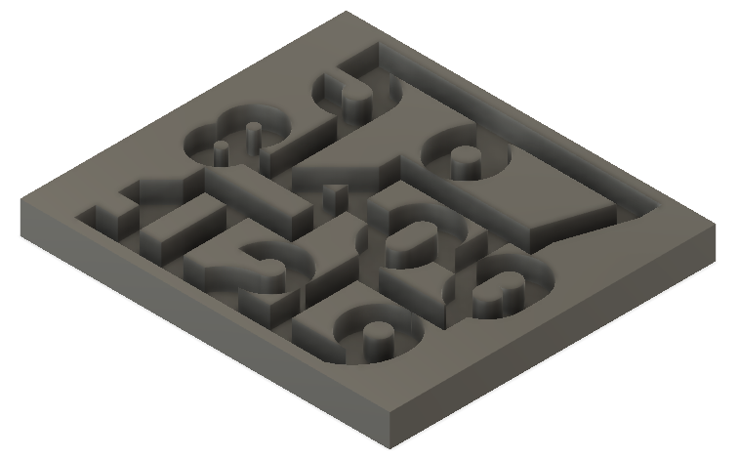

1. **Materials:**

|  |  |  |
| --- | --- | --- |
| **Oder** | **Material** | **Fees (VND)** |
| 1 | Foam paper | 50.000 |
| 2 | Iron circle ( object) | 20.000 |
| 3 | More colors of decal | 50.000 |
| 4 | Magnet | 80.000 |
|  | Total | 200.000 |

**III – PROTOTYPE:**

**1. Prototype 1:**

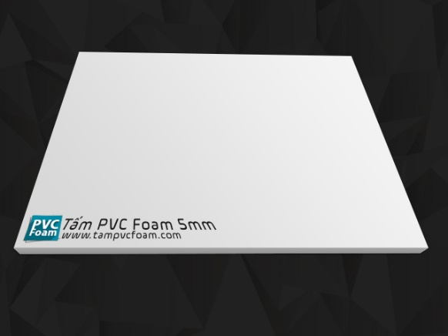

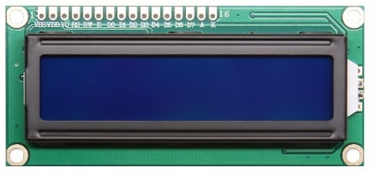

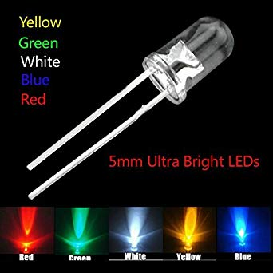

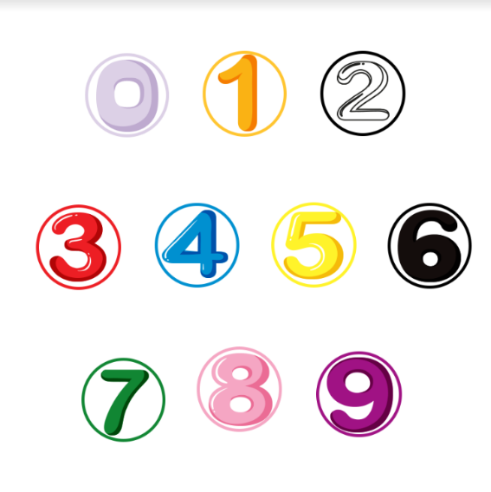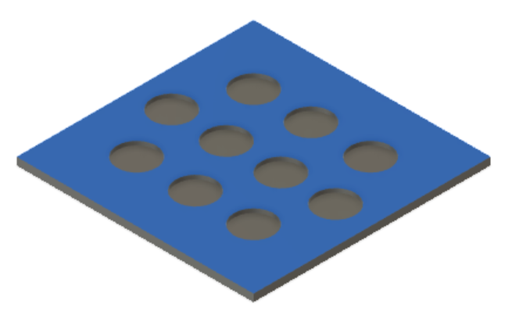

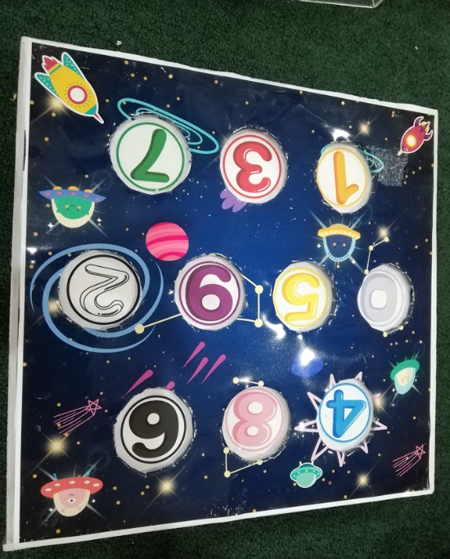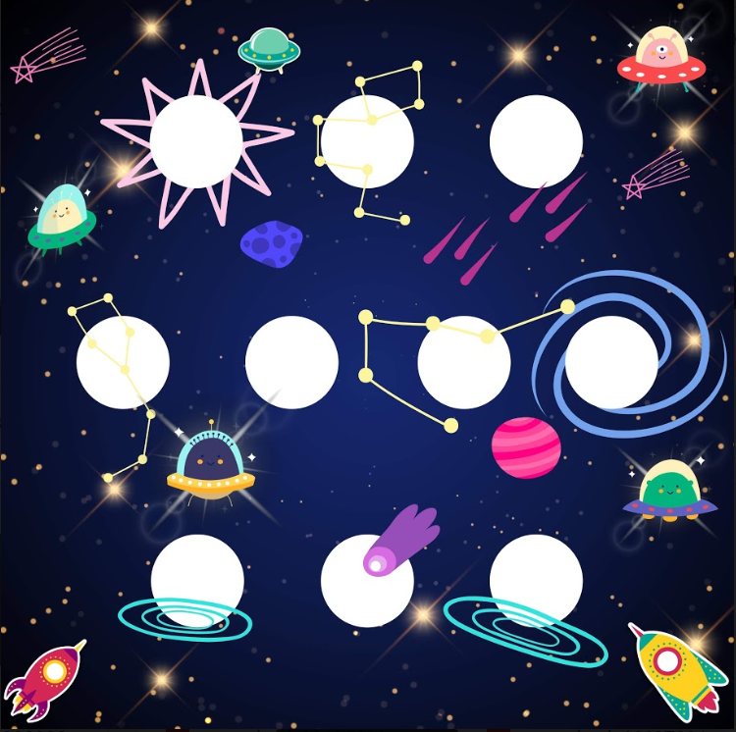

**2. Prototype 2:**

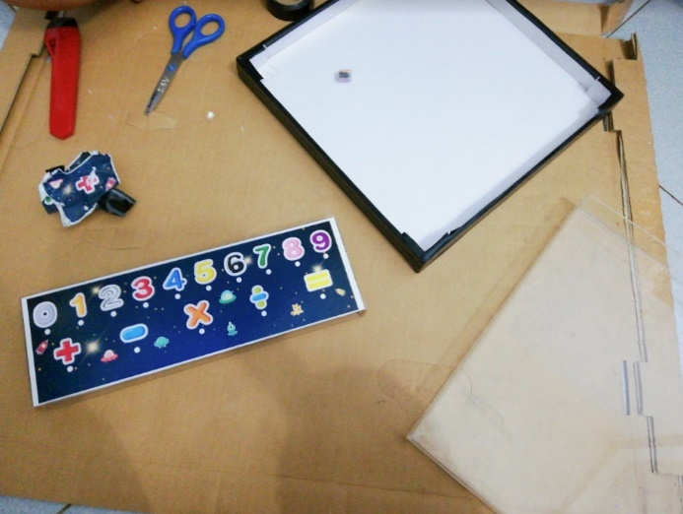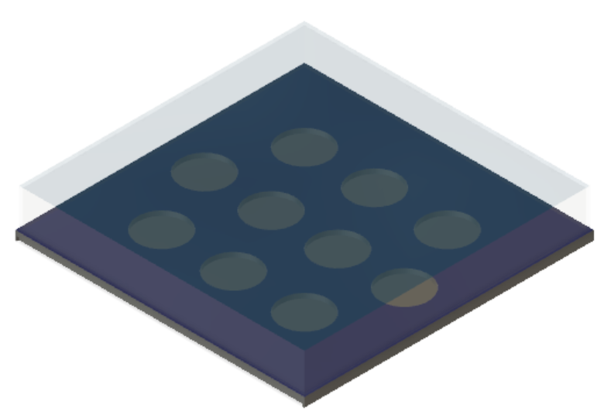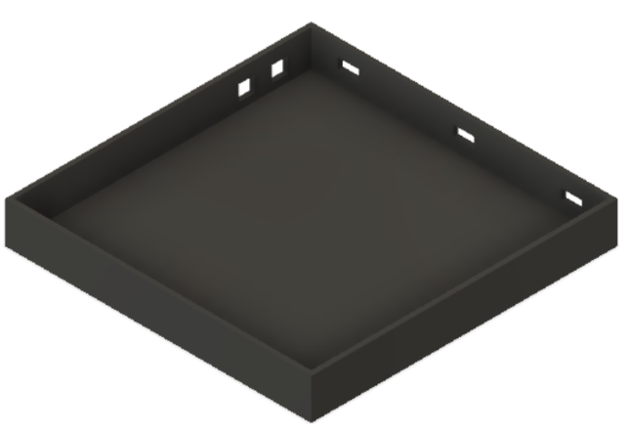

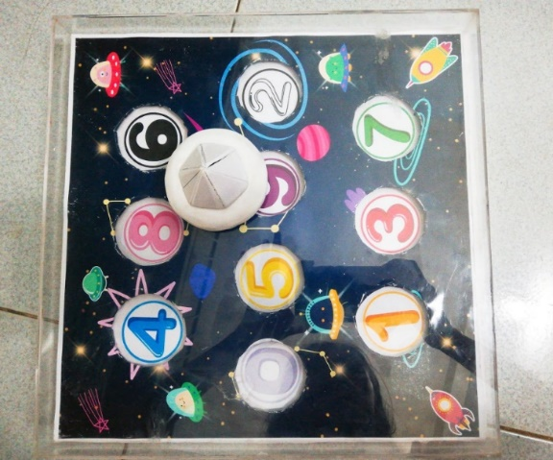

**3. Prototype3:**

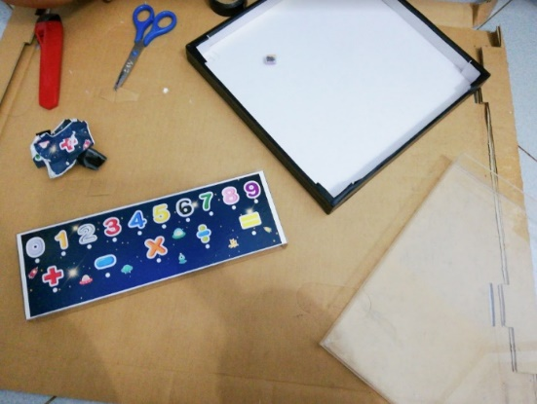

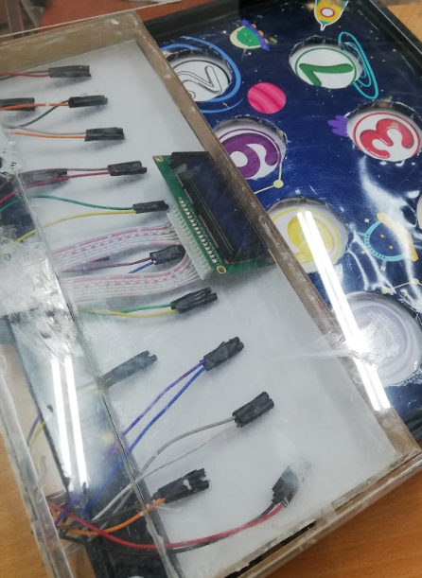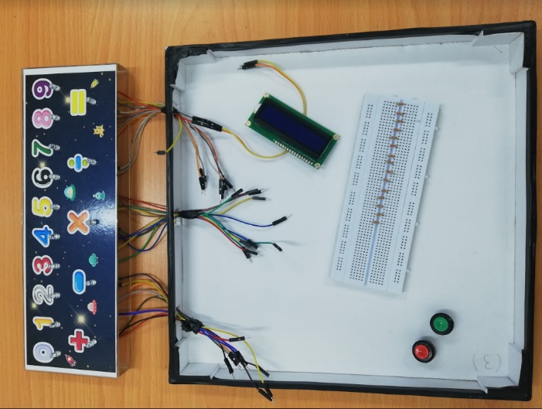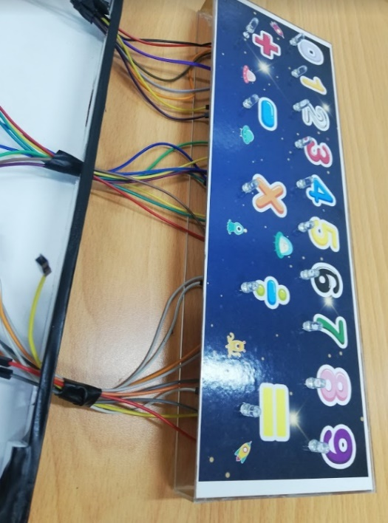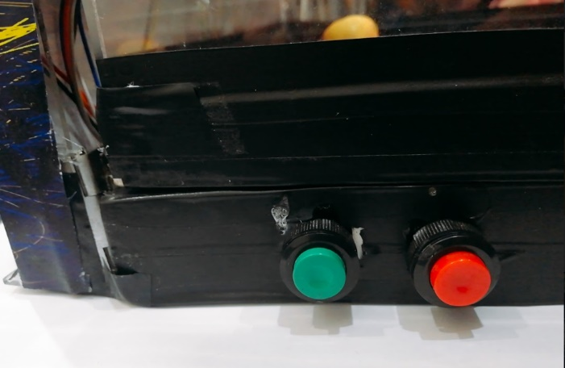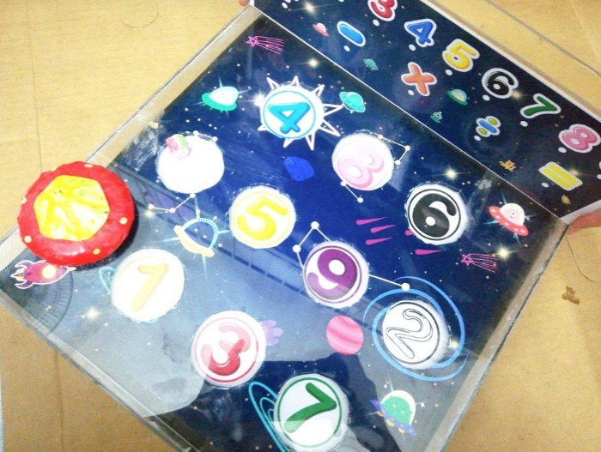

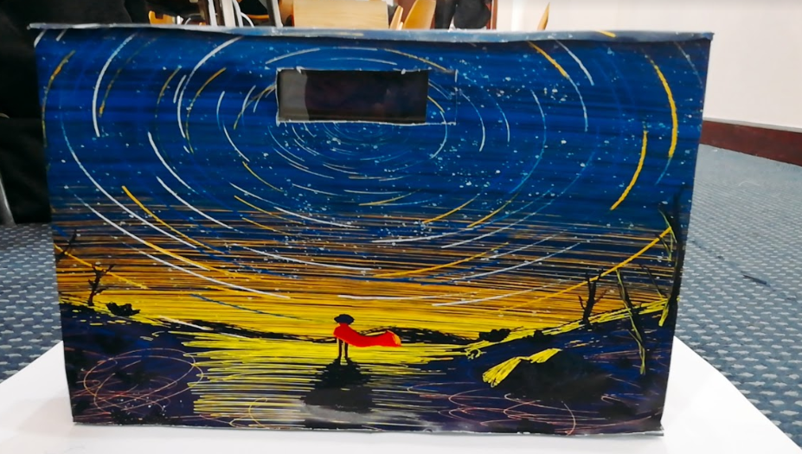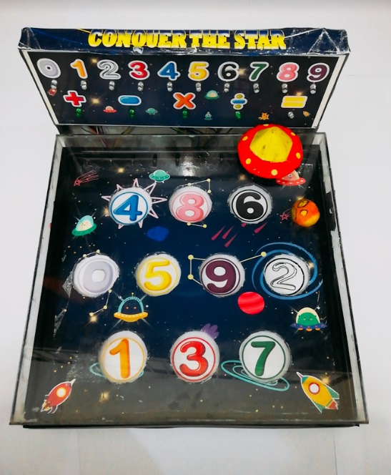

**4. Fees:**

|  |  |  |
| --- | --- | --- |
| Order | Material | Fee (VND) |
| 1 | Foam paper | 50.000 |
| 2 | Paper-knife | 20.000 |
| 3 | Magnet + LCD + registers | 90.000 |
| 4 | Mica | 130.000 |
| 5 | Printing + side things | 75.000 |
| 6 | I2C + jumper | 30.000 |
| 7 | LEDs + button | 30.000 |
| 8 | Services | 20.000 |
| 9 | Unplanned spending | 50000 |
|  | Total fee of materials | 495.000 |

**IV – PRODUCT:**

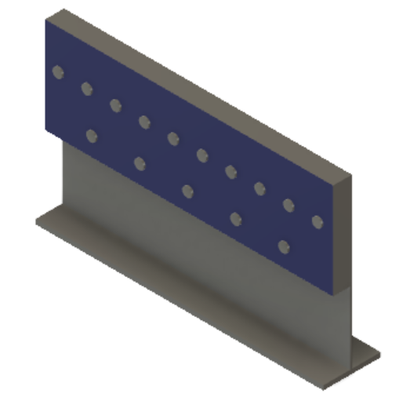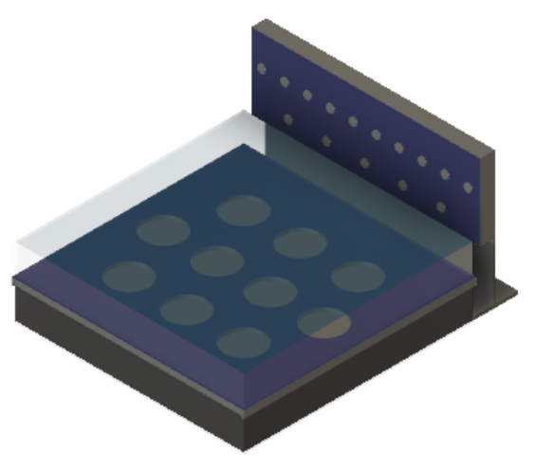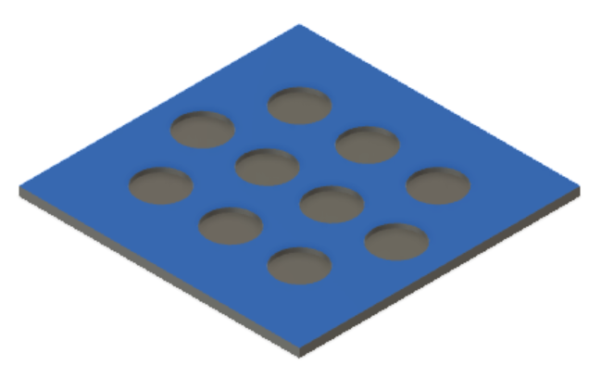**1. Final 3D – design:**

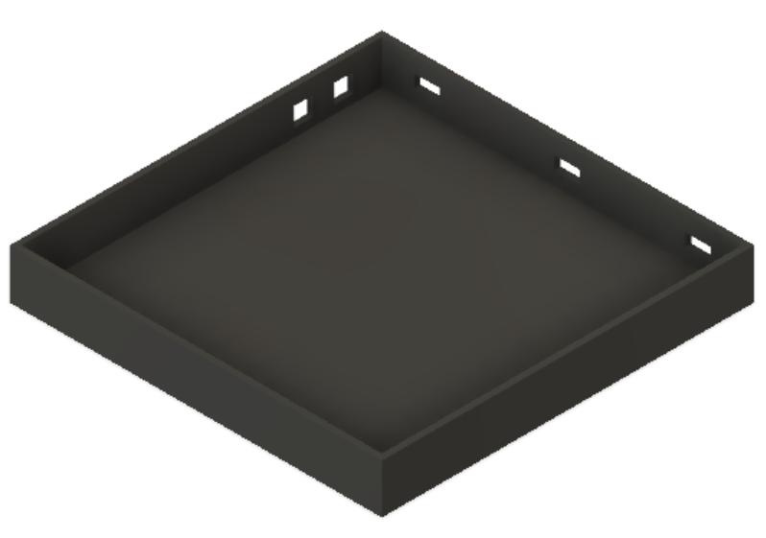



**2. Electrical devices (Number pad):**

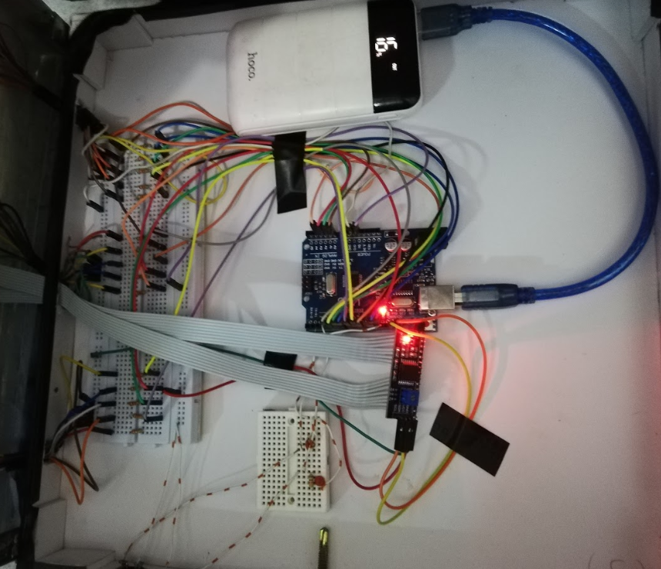

**3. Code:**

#include <Wire.h>

#include <LiquidCrystal_I2C.h>

LiquidCrystal_I2C lcd(0x27,16,2);

int interrupt_pin2 = 2;

int interrupt_pin3 = 3;

long unsigned int time1,time2,tie2=0,tie3,tie1,tie4;

byte t=0,iq=0,cout=0,l=0;

//byte ledPin[0] = 1, ledPin[1] = A1, ledPin[2] = A2, ledPin[3]=A3, ledPin[4]=13, ledPin[5]=A0;

//byte ledPin[6] = 4, ledPin[7] = 5, ledPin[8] = 6, ledPin[9]=7;

//byte ledPin[8] = 8, ledPin[9] = 9, ledPin[10] = 10, ledPin[11]=11, ledPin[14]=12;

byte ledPin[]={1,A1,A2,A3,13,A0,4,5,6,7,8,9,10,11,12};

byte i;

void pin2Interrupt(void)

{

if (l==0)

{

tie3=millis()/1000+2;

l=1;

}

if ((cout < 11) && ( millis()/1000>tie3 ))

{

cout++;

t=0;

l=0;

if ( cout >= 1 && cout <= 3)

iq=iq+1;

if ( cout>= 4 && cout <= 6)

iq=iq+2;

if ( cout>=7 && cout <= 9)

iq=iq+3;

if ( cout == 34)

iq=iq+5;

}

}

void pin3Interrupt(void)

{

if (l==0)

{

tie3=millis()/1000+2;

l=1;

}

if ((cout < 11) && ( millis()/1000 > tie3 ))

{

cout++;

l=0;

t=0;

}

}

void tatled()

{

for ( i=0; i<15;i++) {

digitalWrite(ledPin[i],LOW); //Mặc định các đèn LED sẽ tắt

}

}

void setup()

{

lcd.init();

lcd.backlight();

pinMode(interrupt_pin2, INPUT);

attachInterrupt(0, pin2Interrupt, FALLING);

pinMode(interrupt_pin3, INPUT);

attachInterrupt(1, pin3Interrupt, FALLING);

for (int i=0;i<15;i++) {

pinMode(ledPin[i],OUTPUT); //Các chân LED là OUTPUT

digitalWrite(ledPin[i],LOW); //Mặc định các đèn LED sẽ tắt

}

Serial.begin(9600);

}

void loop()

{

Serial.print("time1=");

Serial.print(time1);

Serial.print("; time2=");

Serial.print(time2);

Serial.print("; IQ=");

Serial.print(iq);

Serial.print("; tie2=");

Serial.print(tie2);

Serial.print("; cout=");

Serial.println(cout);

switch (cout) {

case 0:

if (t == 0)

{

t=1;

lcd.print("Xin chao!den voi");

lcd.setCursor(0,1);

lcd.print("Conquer the stars");

}

time1=millis()/1000;

tie1=millis()/1000;

delay(1000);

break;

case 1:

time2= millis()/1000-tie2;

if (t == 0)

{

delay(1000);

tie2=tie2+time1;

t=1;

lcd.clear();

lcd.setCursor(0,0);

digitalWrite(ledPin[1], HIGH);

}

delay(1000);

break;

case 2:

time1=millis()/1000-tie2;

if (t == 0)

{

tie2=tie2+time2;

lcd.print(time2);

t=1;

digitalWrite(ledPin[1], LOW);

delay(1000);

digitalWrite(ledPin[4], HIGH);

}

delay(1000);

break;

case 3:

time2 = millis()/1000-tie2;

if (t == 0)

{

tie2=tie2+time1;

lcd.print(time1);

lcd.clear();

lcd.setCursor(0,0);

t=1;

digitalWrite(ledPin[4], LOW);

delay(1000);

digitalWrite(ledPin[7], HIGH);

lcd.print(time1);

}

delay(1000);

break;

case 4:

time1=millis()/1000-tie2;

if (t == 0)

{

tie2=tie2+time2;

lcd.clear();

lcd.setCursor(0,0);

t=1;

lcd.print(time2);

digitalWrite(ledPin[7], LOW);

delay(1000);

digitalWrite(ledPin[1], HIGH);

delay(2000);

digitalWrite(ledPin[10], HIGH);

delay(2000);

digitalWrite(ledPin[4], HIGH);

delay(2000);

digitalWrite(ledPin[14], HIGH);

}

delay(1000);

break;

case 5:

time2=millis()/1000-tie2;

if (t == 0)

{

tie2=tie2+time1;

lcd.clear();

lcd.setCursor(0,0);

tatled();

delay(1000);

t=1;

lcd.print(time1);

digitalWrite(ledPin[7], HIGH);

delay(2000);

digitalWrite(ledPin[11], HIGH);

delay(2000);

digitalWrite(ledPin[4], HIGH);

delay(2000);

digitalWrite(ledPin[14], HIGH);

}

delay(1000);

break;

case 6:

time1=millis()/1000-tie2;

if (t == 0)

{

tie2=tie2+time2;

lcd.clear();

lcd.setCursor(0,0);

tatled();

delay(1000);

t=1;

lcd.print(time2);

digitalWrite(ledPin[3], HIGH);

delay(2000);

digitalWrite(ledPin[10], HIGH);

delay(2000);

digitalWrite(ledPin[6], HIGH);

delay(2000);

digitalWrite(ledPin[14], HIGH);

}

delay(1000);

break;

case 7:

time2=millis()/1000-tie2;

if (t == 0)

{

tie2=tie2+time1;

lcd.clear();

lcd.setCursor(0,0);

tatled();

delay(1000);

t=1;

lcd.print(time1);

digitalWrite(ledPin[8], HIGH);

delay(2000);

digitalWrite(ledPin[13], HIGH);

delay(2000);

digitalWrite(ledPin[4], HIGH);

delay(2000);

digitalWrite(ledPin[14], HIGH);

}

delay(1000);

break;

case 8:

time1=millis()/1000-tie2;

if (t == 0)

{

tie2=tie2+time2;

lcd.clear();

lcd.setCursor(0,0);

tatled();

delay(1000);

t=1;

lcd.print(time2);

digitalWrite(ledPin[2], HIGH);

delay(2000);

digitalWrite(ledPin[12], HIGH);

delay(2000);

digitalWrite(ledPin[3], HIGH);

delay(2000);

digitalWrite(ledPin[14], HIGH);

}

delay(1000);

break;

case 9:

time2=millis()/1000-tie2;

if (t == 0)

{

tie2=tie2+time1;

lcd.clear();

lcd.setCursor(0,0);

tatled();

delay(1000);

t=1;

lcd.print(time1);

digitalWrite(ledPin[8], HIGH);

delay(2000);

digitalWrite(ledPin[13], HIGH);

delay(2000);

digitalWrite(ledPin[1], HIGH);

delay(2000);

digitalWrite(ledPin[14], HIGH);

}

delay(1000);

break;

case 10:

time1=millis()/1000-tie2;

if (t == 0)

{

tie2=tie2+time2;

lcd.clear();

lcd.setCursor(0,0);

tatled();

delay(1000);

t=1;

lcd.print(time2);

digitalWrite(ledPin[6], HIGH);

delay(2000);

digitalWrite(ledPin[10], HIGH);

delay(2000);

digitalWrite(ledPin[3], HIGH);

delay(2000);

digitalWrite(ledPin[11], HIGH);

delay(2000);

digitalWrite(ledPin[9], HIGH);

delay(2000);

digitalWrite(ledPin[14], HIGH);

}

delay(1000);

break;

case 11:

time2=millis()/1000-tie2;

tie4=millis()/1000-tie1;

if (t == 0)

{

lcd.clear();

lcd.setCursor(0,0);

tatled();

t=1;

lcd.print(time1);

}

if ( tie4 > 600 )

iq=iq+0;

else

if (tie4>540)

iq=iq+1;

else

if (tie4>480)

iq=iq+2;

else if (tie4>420)

iq=iq+3;

else if (tie4>360)

iq=iq+4;

else if (tie4>300)

iq=iq+5;

else if (tie4>240)

iq=iq+6;

else

iq=iq+7;

delay(10000);

lcd.clear();

lcd.setCursor(0,0);

lcd.print("IQ=");

lcd.print(iq);

lcd.setCursor(0,1);

lcd.print("Total:");

lcd.print(tie4);

delay(10000);

cout=0;

lcd.clear();

lcd.setCursor(0,0);

iq=0;

tie2=0;

t=0;

break;

}

}

**4. Final product:**

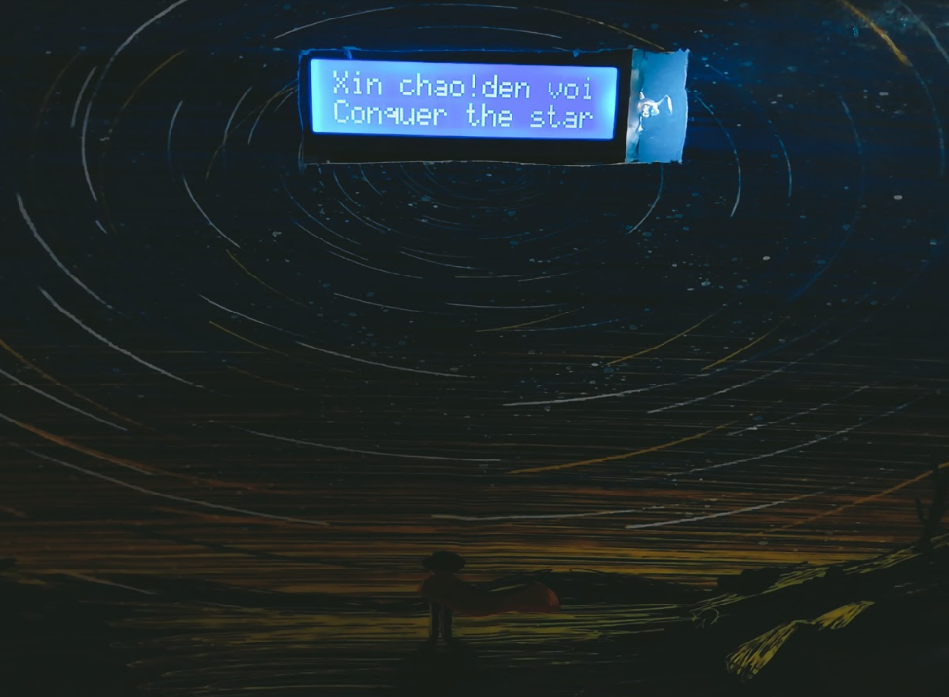



**5. Story of the toy:**

This is not only a toy but also a real story base on material of imaginary friction. you trust me, it will be reality. If not, we do not any thing to prove it. The story is about the UFO controlled by a best human from the Earth. UFO is applied the modern technology can drop down an aerolite to destroy all planet. One day, Lucifer system which include 10 planets, there are threatening to solar system. Mission’s players are controlling UFO to destroy ten stars in Lucifer system and protect the Earth.

Players have to do ten challenges to break wall of planet and then drop down and destroy that star. Good luck to you, be hero!

**6. Principle:**

Player will control the UFO to destroy ten planet like numbers by dropping out the aerolite. Children look at number pad, then LEDs will be lighted, according to ten coded questions, people must memorize the operation and have the result form calculation.

The list of the challenges:

**I) Easy:** Numbers

|  |  |  |  |
| --- | --- | --- | --- |
| Level | 1 | 2 | 3 |
| Request | Go to number 1 | Go to number 4 | Go to number 7 |
| Answer | Move object to the land No. 1 | Move object to the land No.4 | Move object to the land No.7 |
| Complete | +1 | +1 | +1 |

**II) Medium**: Add and subtract

|  |  |  |  |
| --- | --- | --- | --- |
| Level | 4 | 5 | 6 |
| Request | Colored land (number 1) plus colored land (number 4) is? | Colored land (number 7) minus colored land (number 4) is? | Colored land (number 3) plus colored land (number 6) is? |
| Answer | Move object to the land No.5 | Move object to the land No. 3 | Move object to the land No.9 |
| Complete | +2 | +2 | +2 |

**III) Hard**: multiply and devide

|  |  |  |  |
| --- | --- | --- | --- |
| Level | 7 | 8 | 9 |
| Request | Colored land (number 8) divided colored land (number 4) is? | Colored land (number 2) multiply colored land (number 3) is? | Colored land (number 8) divided colored land (number 1) is? |
| Answer | Move people to the land No.2 | Move people to land No. 6 | Move people to the land No.8 |
| Complete | +3 | +3 | +3 |

**IV/ Very hard**: complex operation

Requirement: Colored land (number 6) plus colored land (number 3) minus colored land (number 9) is?

Answer: Move people to the land No.0

Completa: +5

Completing this magical journey, including 10 problems equivalent to 10 small lands, finally the alien have discovered all of this fairy land.

Total points decrease: +23

Space base on the average time:

Average time = ( Total time) / N level

< 30 second: +7

30 - 36 second: +6

36 - 42 second: +5

42 - 48 second: +4

48 - 54 second: +3

54 - 60 second: +2

60 - 66 second: +1

>66 second: +0

Maximum value is 30 points. Note: The value is only true when the child's age is not more than 12, this is true because the deseases children are mostly less than 12 years old.

**Example in Level 3:**

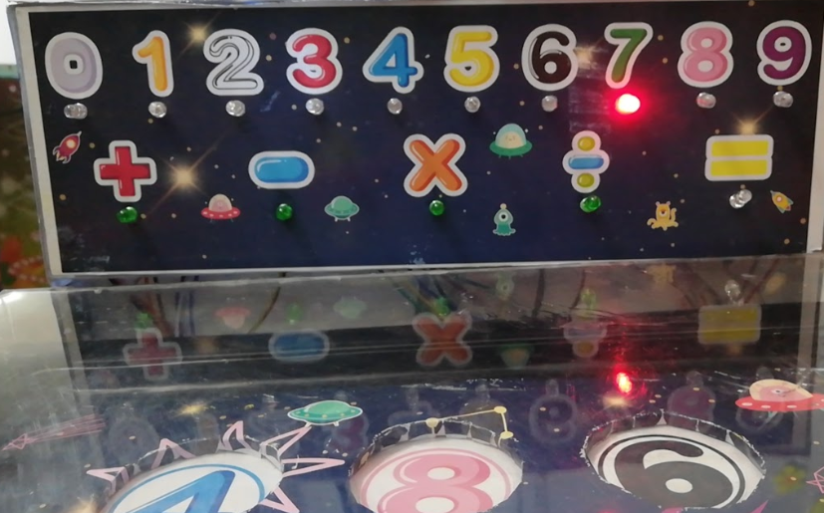

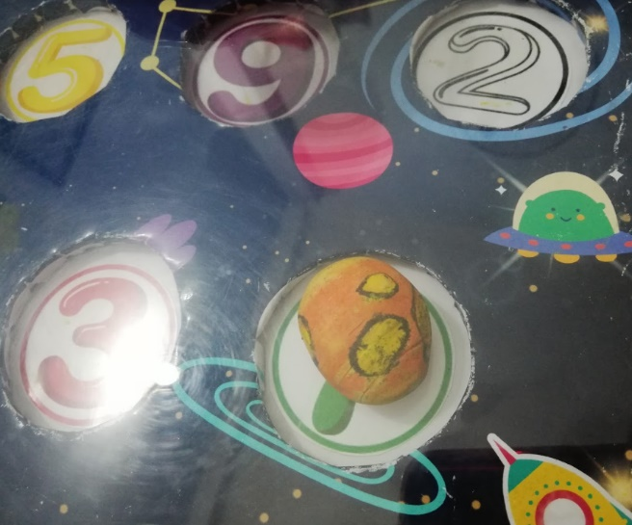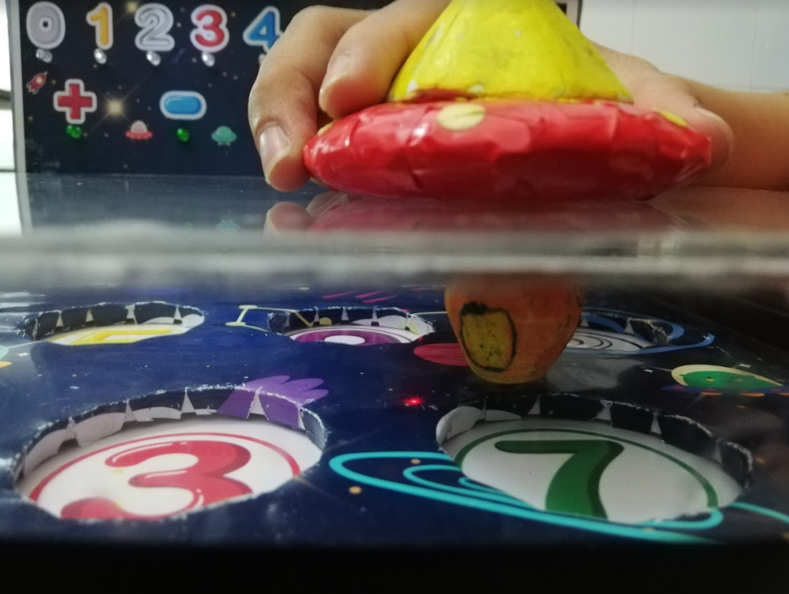

**7. Price:**

|  |  |  |
| --- | --- | --- |
| Order | Content | Price (VND) |
| 1 | Materials | 495.000 |
| 2 | Coding | 900.000 |
| 3 | Decoration | 500.000 |
| 4 | Build hardware | 500.000 |
| 5 | Validation by tests | 500.000 |
| Total price for a product | | 2.895.000 |

**V – COLLECT DATA AND ANALYSIS:**

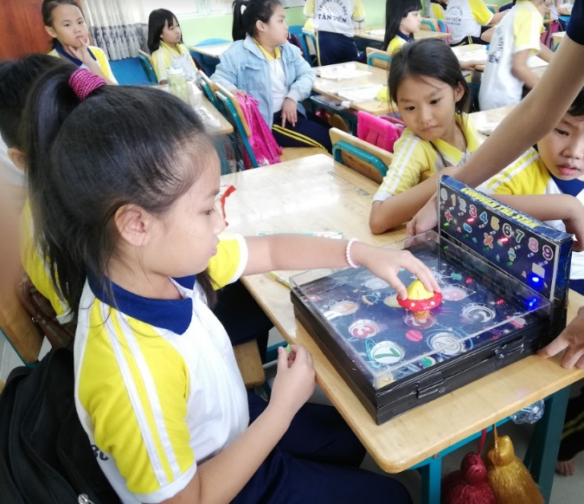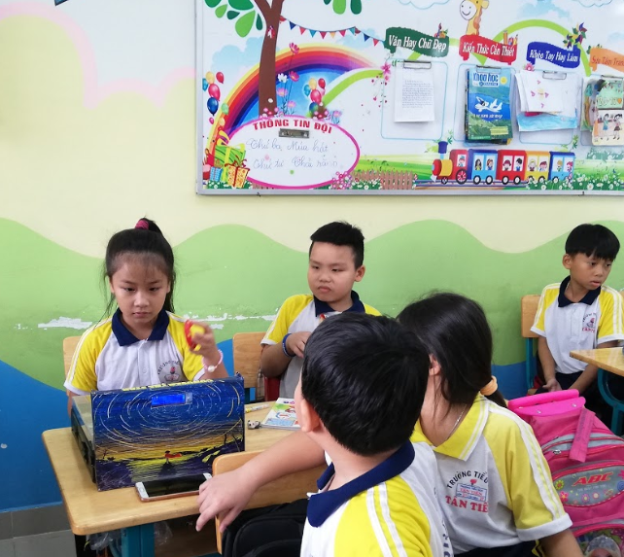**1. Testing:**

Normal children

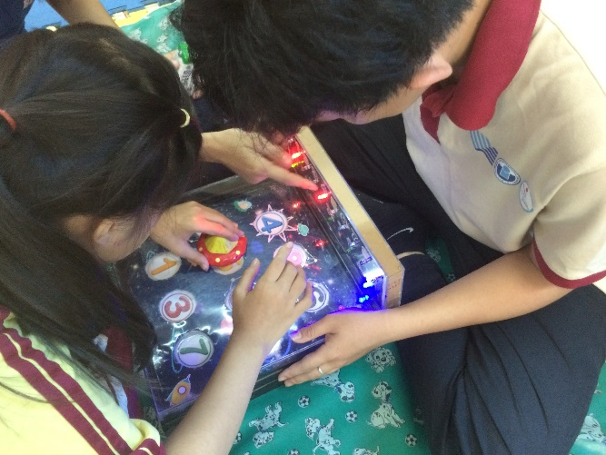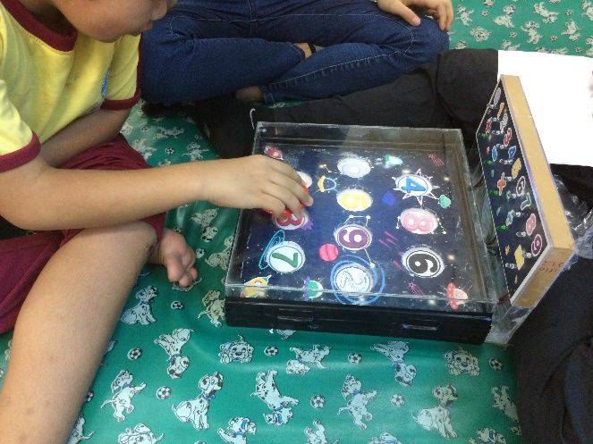Disable children

**2. Validation**:

2.1. Data from disable children:

|  |  |  |  |  |  |  |  |  |  |
| --- | --- | --- | --- | --- | --- | --- | --- | --- | --- |
| Order | Gender | Age | Ability | Level passed | Time | Total time | Average  Time | X | Observation |
| 1 | Female | 8 | Underdevelop | 1 2 3 | 20 19 13 | 52 | 17.33 | 10 | - Low  - Know numbers and colors.  - Unknow addition and subtraction |
| 2 | Male | 12 | Attention deficit hyperactivity disorder | 1 2 3 4 5 6 | 26 11 18 35 25 39 | 154 | 25.67 | 16 | - Medium  - Know numbers and colors.  - Calculate addition and subtraction clearly. |
| 3 | Male | 10 | Attention deficit hyperactivity disorder | 1 2 3 4 5 6 | 18 11 12 20 30 32 | 123 | 20.5 | 16 | - Medium  - Know numbers and colors.  - Calculate addition and subtraction clearly. |
| 4 | Male | 10 | Attention deficit hyperactivity disorder | 1 2 3 4 5 6 | 11 16 29 31 28 33 | 148 | 24.67 | 16 | - Medium  - Know numbers and colors.  - Calculate addition and subtraction clearly. |
| 5 | Female | 10 | Down | 1 2 3 | 20 19 33 | 72 | 24 | 10 | - Low  - Know numbers and colors.  - Unknow addition and subtraction. |
| 6 | Male | 10 | Down | 1 2 3 | 14 15 16 | 45 | 15 | 10 | - Low  - Know numbers and colors.  - Unknow addition and subtraction. |
| 7 | Male | 10 | Know English Poor memory | 1 2 3 4 | 9 7 7 37 | 60 | 20 | 12 | - Medium  - Know numbers and colors.  - Unknow addition and subtraction exactly. |
| 8 | Female | 11 | Down (high level) | 1 | 59 | 59 | 59 | 3 | - Low  - Unknow numbers and colors.  - Unknow addition and subtraction. |
| 9 | Female | 12 | Down | 1 2 3 4 5 6 | 16 11 11 28 24 34 | 124 | 20.67 | 16 | - Medium  - Know numbers and colors.  - Calculate addition and subtraction clearly. |
| 10 | Female | 8 | Underdevelop | 1 2 | 60 58 | 118 | 59 | 4 | - Low  - Know numbers and colors.  - Unknow addition and subtraction. |
| 11 | Male | 9 | Down | 1 2 3 | 49 80 29 | 158 | 52.67 | 6 | - Low  - Know numbers and colors.  - Unknow addition and subtraction. |
| 12 | Female | 10 | Attention deficit hyperactivity disorder | 1 2 3 | 55 40 20 | 115 | 38.33 | 8 | - Low  - Know numbers and colors.  - Unknow addition and subtraction. |
| 13 | Female | 9 | Down | 1 2 3 | 49 30 26 | 105 | 35 | 9 | - Low  - Know numbers and colors.  - Unknow addition and subtraction. |
| 14 | Male | 8 | Down | 1 2 3 | 35 30 36 | 101 | 33.67 | 9 | - Low  - Know numbers and colors.  - Unknow addition and subtraction. |

|  |  |  |  |  |  |  |  |  |  |
| --- | --- | --- | --- | --- | --- | --- | --- | --- | --- |
| Order | Gender | Age | Ability | Level passed | Time | Total time | Average  Time | X | Observation |
| 1 | Female | 10 | Autism | 1 2 3 4 5 6 | 13 14 24 30 40 31 | 152 | 25.33 | 16 | - Medium  - Know numbers and colors.  - Calculate addition and subtraction clearly. |
| 2 | Male | 8 | Attention deficit hyperactivity disorder Autism | 1 2 3 4 5 6 | 10 10 10 33 31 44 | 138 | 23 | 16 | - Medium  - Know numbers and colors.  - Calculate addition and subtraction clearly. |
| 3 | Male | 8 | Attention deficit hyperactivity disorder Autism | 1 2 3 | 24 21 41 | 86 | 28.67 | 10 | - Low  - Know numbers and colors.  - Unknow addition and subtraction. |
| 4 | Female | 11 | Attention deficit hyperactivity disorder Autism | 1 2 3 4 5 6 | 8 11 14 35 40 48 | 156 | 26 | 16 | - Medium  - Know numbers and colors.  - Calculate addition and subtraction clearly. |
| 5 | Male | 11 | Attention deficit hyperactivity disorder Autism | 1 2 3 4 5 6 | 15 15 16 29 36 24 | 135 | 22.5 | 16 | - Medium  - Know numbers and colors.  - Calculate addition and subtraction clearly. |
| 6 | Male | 10 | Attention deficit hyperactivity disorder Autism | 1 2 3 4 5 6 | 10 12 18 43 28 59 | 170 | 28.33 | 16 | - Medium  - Know numbers and colors.  - Calculate addition and subtraction clearly. |
| 7 | Female | 10 | Attention deficit hyperactivity disorder Autism | 1 2 3 4 5 6 | 8 7 13 20 25 38 | 111 | 18.5 | 16 | - Medium  - Know numbers and colors.  - Calculate addition and subtraction clearly. |
| 8 | Male | 10 | Attention disorder | 1 2 3 4 5 6 | 15 14 27 102 44 60 | 262 | 43.67 | 13 | - Medium  - Know numbers and colors.  - Know calculation by directing from teacher. |
| 9 | Female | 12 | Attention deficit hyperactivity disorder Autism | 1 2 3 4 5 6 | 19 14 10 27 16 45 | 131 | 21.83 | 16 | - Medium  - Know numbers and colors.  - Calculate addition and subtraction clearly. |
| 10 | Female | 12 | Underdevelop | 1  2  3 | 65  70  52 | 187 | 62.33 | 4 | - Low  - Know numbers and colors slowly.  - Unknow addition and subtraction. |

2.2.Data from normal children:

|  |  |  |  |  |  |  |  |  |  |
| --- | --- | --- | --- | --- | --- | --- | --- | --- | --- |
| Order | Gender | Age | Ability | Level passed | Time | Total time | Average  Time | X | Observation |
| 1 | Female | 8 | Normal | 1 2 3 4 5 6 7 8 9 10 | 9 8 10 15 17 19 19 20 15 23 | 155 | 15.5 | 30 | - High  - Know numbers and colors clearly.  - Know addition and subtraction very fast.  - Calculate multiply and divided operation exactly. |
| 2 | Male | 8 | Normal | 1 2 3 4 5 6 7 8 9 10 | 10 9 10 15 16 18 19 20 20 26 | 163 | 16.3 | 30 | - High  - Know numbers and colors clearly.  - Know addition and subtraction very fast.  - Calculate multiply and divided operation exactly. |
| 3 | Male | 8 | Smart | 1 2 3 4 5 6 7 8 9 10 | 8 7 7 15 16 15 16 15 15 24 | 138 | 13.8 | 30 | - High  - Know numbers and colors clearly.  - Know addition and subtraction very fast.  - Calculate multiply and divided operation exactly. |
| 4 | Female | 8 | Excellent | 1 2 3 4 5 6 7 8 9 10 | 8 8 10 15 15 17 15 20 15 22 | 145 | 14.5 | 30 | - High  - Know numbers and colors clearly.  - Know addition and subtraction very fast.  - Calculate multiply and divided operation exactly. |
| 5 | Female | 9 | Normal | 1 2 3 4 5 6 7 8 9 10 | 10 8 7 20 15 17 15 19 15 25 | 151 | 15.1 | 30 | - High  - Know numbers and colors clearly.  - Know addition and subtraction very fast.  - Calculate multiply and divided operation exactly. |
| 6 | Female | 9 | Normal | 1 2 3 4 5 6 7 8 9 10 | 10 9 7 18 20 17 15 19 15 25 | 155 | 15.5 | 30 | - High  - Know numbers and colors clearly.  - Know addition and subtraction very fast.  - Calculate multiply and divided operation exactly. |
| 7 | Male | 9 | Good | 1 2 3 4 5 6 7 8 9 10 | 7 11 7 15 17 17 21 19 15 25 | 154 | 15.4 | 30 | - High  - Know numbers and colors clearly.  - Know addition and subtraction very fast.  - Calculate multiply and divided operation exactly. |
| 8 | Male | 10 | Normal | 1 2 3 4 5 6 7 8 9 10 | 10 9 8 15 16 18 21 20 20 26 | 163 | 16.3 | 30 | - High  - Know numbers and colors clearly.  - Know addition and subtraction very fast.  - Calculate multiply and divided operation exactly. |
| 9 | Male | 10 | Normal | 1 2 3 4 5 6 7 8 9 10 | 9 8 10 15 17 19 19 15 15 23 | 147 | 14.7 | 30 | - High  - Know numbers and colors clearly.  - Know addition and subtraction very fast.  - Calculate multiply and divided operation exactly. |
| 10 | Female | 10 | Excellent | 1 2 3 4 5 6 7 8 9 10 | 10 8 7 15 15 17 15 19 15 20 | 141 | 14.1 | 30 | - High  - Know numbers and colors clearly.  - Know addition and subtraction very fast.  - Calculate multiply and divided operation exactly. |
| 11 | Female | 10 | Good | 1 2 3 4 5 6 7 8 9 10 | 9 8 10 15 17 19 19 19 15 23 | 154 | 15.4 | 30 | - High  - Know numbers and colors clearly.  - Know addition and subtraction very fast.  - Calculate multiply and divided operation exactly. |

2.3. Analysis data and Validation**:**

|  |  |
| --- | --- |
| X | Learning |
| 0-10 | Low |
| 11-16 | Medium |
| 17-25 | Good |
| 26-30 | High |

|  |  |  |  |
| --- | --- | --- | --- |
|  | Disable 1 | Disable 2 | Normal |
| 1 | 100%(14) | 100%(10) | 100%(11) |
| 2 | 92.86%(13) | 100% | 100% |
| 3 | 85.71%(12) | 100% | 100% |
| 4 | 35.71%(5) | 80% | 100% |
| 5 | 28.57%(4) | 80% | 100% |
| 6 | 28.57%(4) | 80% | 100% |
| 7 | 0% | 0% | 100% |
| 8 | 0% | 0% | 100% |
| 9 | 0% | 0% | 100% |
| 10 | 0% | 0% | 100% |

|  |  |  |  |
| --- | --- | --- | --- |
|  | Female | Male | Total |
| Disable | 50% | 50% | 14 |
| Disable | 50% | 50% | 10 |
| Normal | 54.55% | 45.45 | 11 |

|  |  |  |  |  |  |  |
| --- | --- | --- | --- | --- | --- | --- |
| Level | 8 | 9 | 10 | 11 | 12 | TOTAL |
| Disable | 3 | 2 | 6 | 1 | 2 | 14 |
| Disable | 2 | 0 | 4 | 2 | 2 | 10 |
| Normal | 4 | 3 | 4 | 0 | 0 | 11 |

**VI – DISCUSSION:**

The quantity of disable children can know numbers and colors in our toy is about 92.86% ( in Specialized School) and 100% ( in Khai Tri School)

The quantity of disable children know the calculation of addition and subtraction between 30.95% and 80% ( in Specialized School and Khai Tri School). There are more difference in person’s ability, or they were learned dissimilar lessons from educational environment, and the ratio of children in the variance of age have the change.

The quantity of disable children can do the multiply and dividing operation at

0% ( for twenty-five student in both schools). Their teacher said that they did not teach children the division and multiplication at that class.

In normal children, one hundred percent of them can make ten challenges exactly in less time and get maximum score for each level.

Otherwise, disable children have difficulty in looking at number pad ( attention disorder), and then memorize the calculation to do it ( some of people unknown addition or subtraction), so they pass some of challenges rightly during a long time.

About the toy: During the testing, the toy operates in stable condition by arduino and electrical devices. The button is quiet sensitive when monitor push up, LED lights up and LCD show more data such as completed time or each level, total time and total score of calculation.

**VII – WORKING PLANING:**

|  |  |  |
| --- | --- | --- |
| **Order** | **Name** | **Working** |
| 1 | Vũ Lê Ngọc Huyền | - Group leader.  - Creating and developing idea project.  - Checking list works and reminding to complete the project on time.  - Managing working time of group members.  - Buying mica and foam paper.  - Making the UFO and mica box.  - Writing ten operations.  - Testing  - Make the statistic table form testing data.  - Completing written report. |
| 2 | Nguyễn Ngọc  Tuyền Vy | - Developing idea project.  - Building 3D prototypes designed by Fusion.  - Making gantt chart.  - Design the background in decal, print and paste them on top side of the toy.  - Design the background of represented-questions box.  - Completing boxes in prototype handmade.  - Design number pad handmade.  - Decorating engineer.  - Testing. |
| 3 | Tăng Lê  Quang Minh | - Developing idea project.  - Design cover of report.  - Design and print the poster.  - Cut pieces of foam paper and connect mica with each others.  - Purchase the electrical devices (led, buttons, I2C, jumpers,...)  - Final completing the represented-questions in mica box with wires and led, LCD, v..v..  - Electrical engineer.  - Testing. |
| 4 | Đinh Hoàng Sáng | - Creating and developing idea project.  - Determining the principle of toy.  - Design the mode of operation during  enjoy the toy.  - Cut pieces of foam paper.  - Buying magnets, LCD, resistors,…  - Writing code for operating the system: to represent data on LCD, lighting up led following questions, calculate grades after playing game,…  - Creating the IQ equation for disable kids. |

**VIII – REFERENCES:**

https://services.anu.edu.au/human-resources/respect-inclusion/different-types-of-disabilities